How to use external DNS servers in CCS

# Objective

This document describes a way to add external DNS servers to instances configuration.

# Overview

This is done by adding the external DNS servers to the subnets.

* Make sure you have a router to connect to the public internet.
* Make sure your security groups allow outgoing traffic for DNS lookup. The default security group allows it.
* Add the external DNS server to your subnets

# Assumption

In this document, we assume that the readers know how to setup router and security group. We will focus on the DNS setting.

If you would like to use OpenStack command line, and have not set up an environment. You can find the description in this document “How to access CCS environment from command line”. <https://cisco.app.box.com/files/0/f/2218526263/1/f_19904760991>

# Recommended DNS servers

These DNS servers are recommended by Cisco.

* 171.70.168.183
* 173.36.131.10
* 173.37.87.157

# Defining external DNS servers

This can be done through Horizon or command line.

## Horizon

If you only have a couple of subnets to update, Horizon is easier to use. You can open the network section, and find the subnet to update. In the following example, you will find the button “Edit Subnet” in the lower right corner.

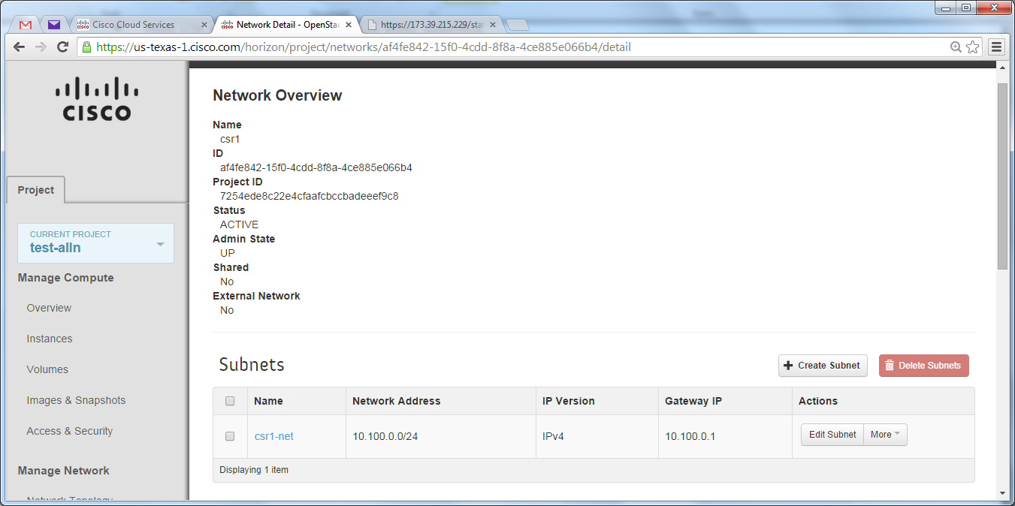

Then, in the “Subnet Detail” tab, you will find the box to add external DNS servers.

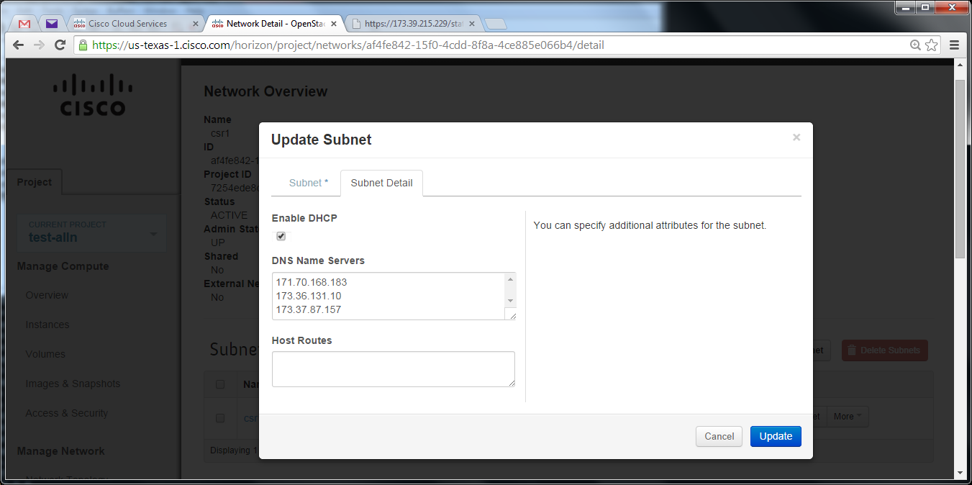

## Command line

You can update your subnet with this 2-line SHELL script. In my case, the network address is 10.3.0.0

**net_ip=10.3.0.0**

**neutron subnet-update $(neutron net-list|grep ${net_ip}|cut -f4 -d"|"|cut -f2 -d" ") \**

**--dns_nameservers list=true 171.70.168.183 173.36.131.10 173.37.87.157**

**You just need to update the network address, and run the command for each subnet.**